Student A part: 25i-3059

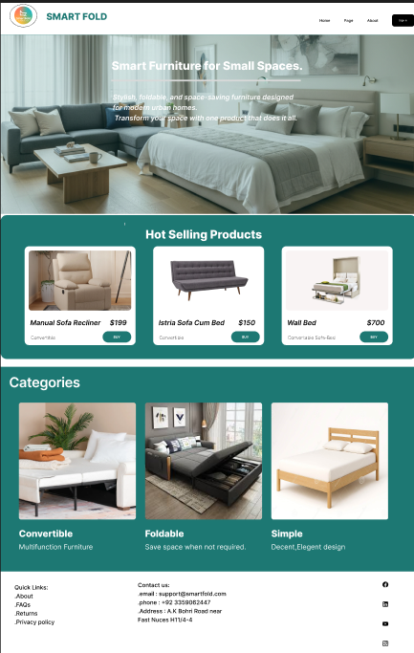
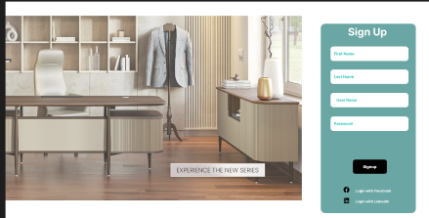
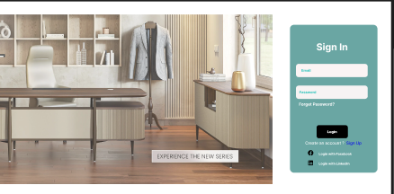
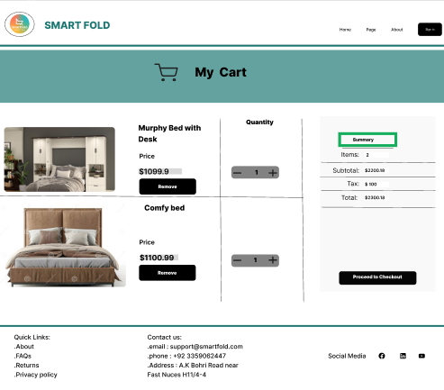
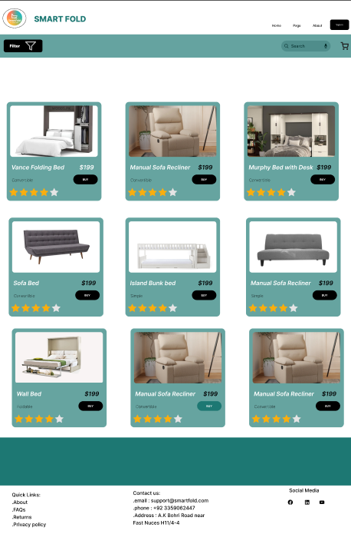
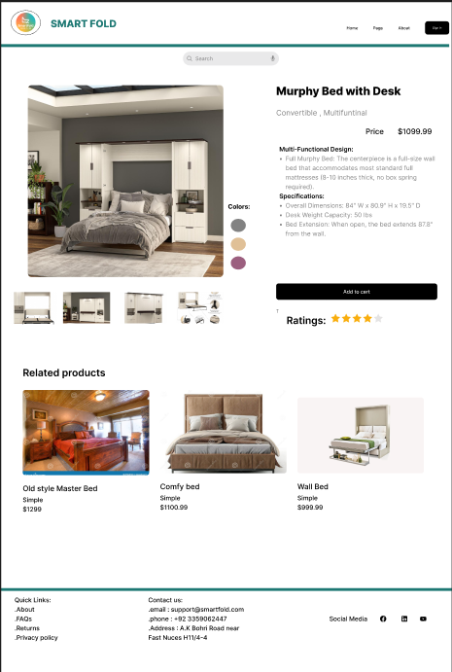

Sudent B part: 25i-3093
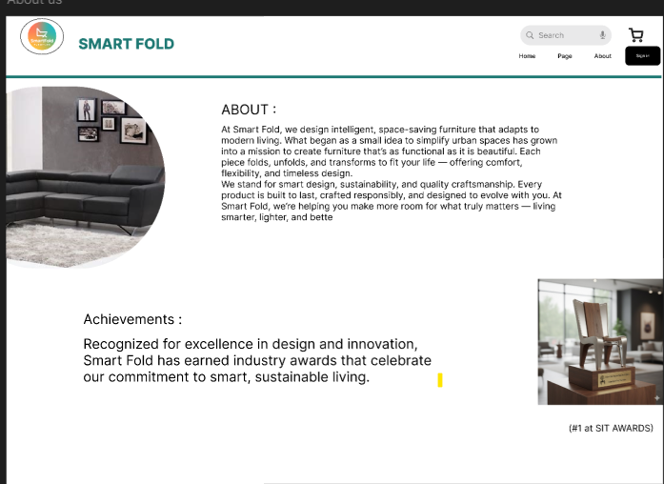
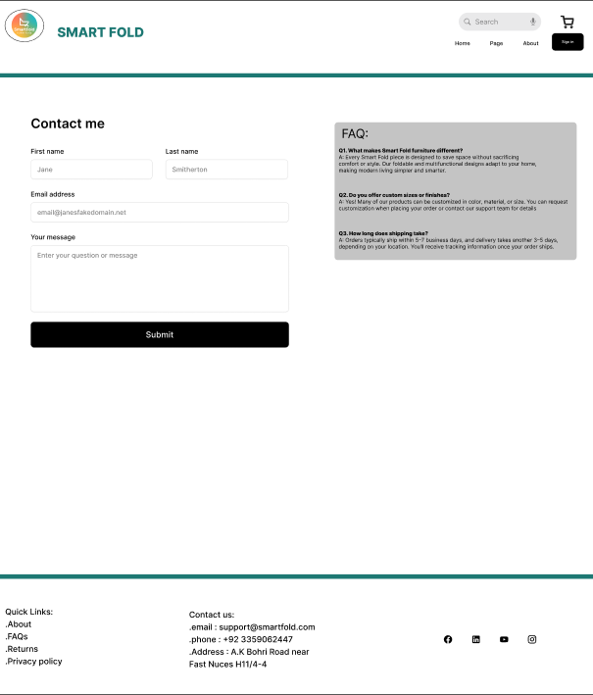

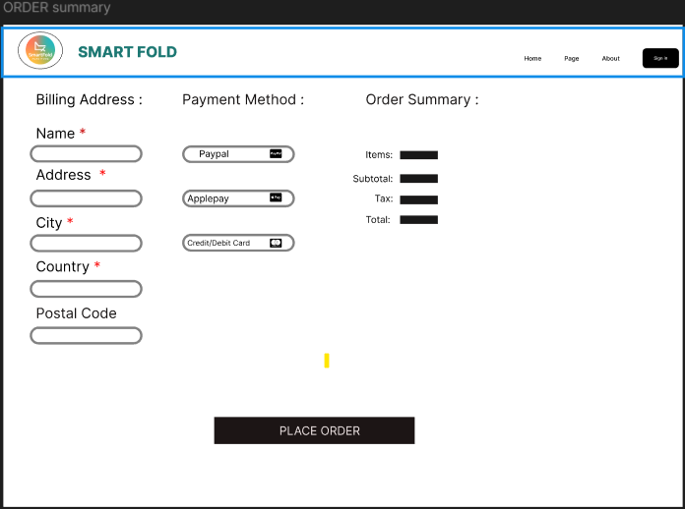
Documentation:
The Smartfold website design embraces a clean, modern, and minimal aesthetic. We use the Inter font for all text to ensure readability and consistency. The color palette features black and white as primary tones, with #1D7873 (68%) used for highlights and accents to create visual emphasis. This balanced combination enhances clarity and gives the interface a sleek, professional appearance. Every picture is clearly shown.
Main BackGround:
White
Sub Backgrounds:
#1D7873 (68%)
#1D7873 (100%)
828282 (5%)
Buttons:
Black background with white/Black Text.
Font:
Inter throughout whole, designing the web.

